USMA MEMBERSHIP APPLICATION

A little information and background: USMA, started in 1979, has been recognized for many years as the most charitable car club in the U.S.A. These are facts recognized by Eagle One Products Co. and Valvoline Motor Oil. Our members support the many, many charities, the many fundraisers we do. For example: Eighteen years of Shriner Hospitals for Children indoor shows raising over $200,000.00, 25 years of Handicapped Boy Scouts Troup 390 raising over $90,000.00, 28 years of M.D. shows raising over $75,000.00, 15 years of working with Vietnam Veterans Chapter 133 Oakland County raising over $50,000.00 to building a Memorial, the Sterling Lions, Clawson Lions eighteen years over $100,000.00, Clawson-Troy Elks, Harper Woods Dads Club and the Oakland County branch YWCA. This just touches the tip of our support through our members' efforts.
We currently do many shows and cruise nites for you to enjoy. There are no mandatory meetings. It's your choice to learn about what we do and how we do our events. We have the finest staff of dedicated workers in our sport, from the registration workers to our proven best judging system in the world. Our booth staff is there to answer questions and help to make your stay with us at a cruise or show an enjoyable time. Rockin' Ronnie DJ's at our events. We encourage our members to support our sponsors. With membership you will receive two window decals and one I.D. card. Thank you for your interest. Everyone is welcome. All makes, all models; we want people who enjoy the sport and have some fun with cars. Any questions, please ask.
Our plan is to do USMA car and truck events through the next few seasons or longer depending upon health, help, support and degree of availability. Our intention from the beginning is to offer the very best in car show and cruise entertainment. We set the standards, we raised the bar.
Our members are our first concern. We have had just shy of seven thousand pass through our membership ranks. People join for many reasons. Some stay, others feel the car show rush for a few years and move on. Some like to be part of the best.
We have made the statement since we started in 1979. We will do all we can for our sport for as long as we can. When it's time to stop pressing forward we will know and will adjust to what the market is calling for in events. Maybe a much reduced schedule of good shows.
Anyone who joins pays a one time fee for the life of USMA. That one time fee will be $40.00; you're good for two, four or more years of good time events with no fees to pay for being a member.
We will continue to expand our website. Our email list is growing. You can go to Facebook. We will do direct mailings.

We at United Street Machines thank you for wanting to be part of our car club.

USMA, 430 N. Batchewana, Clawson, MI 48017
Phone: 248-435-3091 E-mail: usmainc@hotmail.com
Website: www.unitedstreetmachines.com
Facebook: www.facebook.com/usmamich

Lifetime membership $40.00 ________

Name: __________________________________________________________________________________________
(Please print clearly)

Address: _________________________________________________________________________________________

City: ___________________________________State: _______ Zip Code: ________Phone: ______________________

Email address: _____________________________ VehicleYr/Make/Model: ___________________________________

OFFICIAL USE ONLY: Date: ____________________ Decals: ________

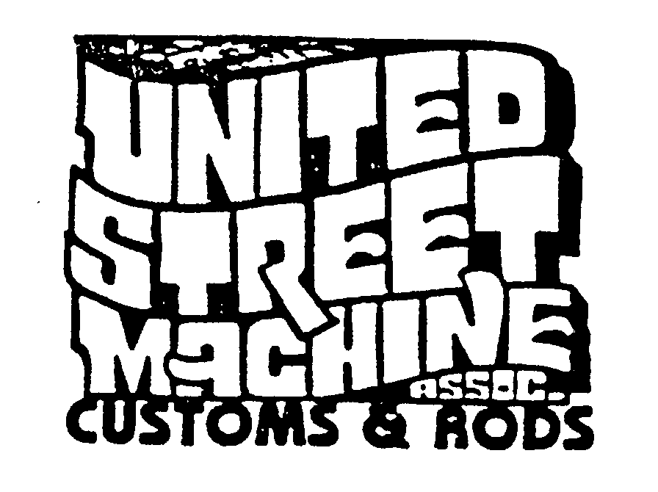
United Street Machines, UNITED STREET MACHINE ASSOC
Most Charitable Car Club 430 N BATCHEWANA
In the Midwest CLAWSON MI 48017

